WireFrames:
Sign in page
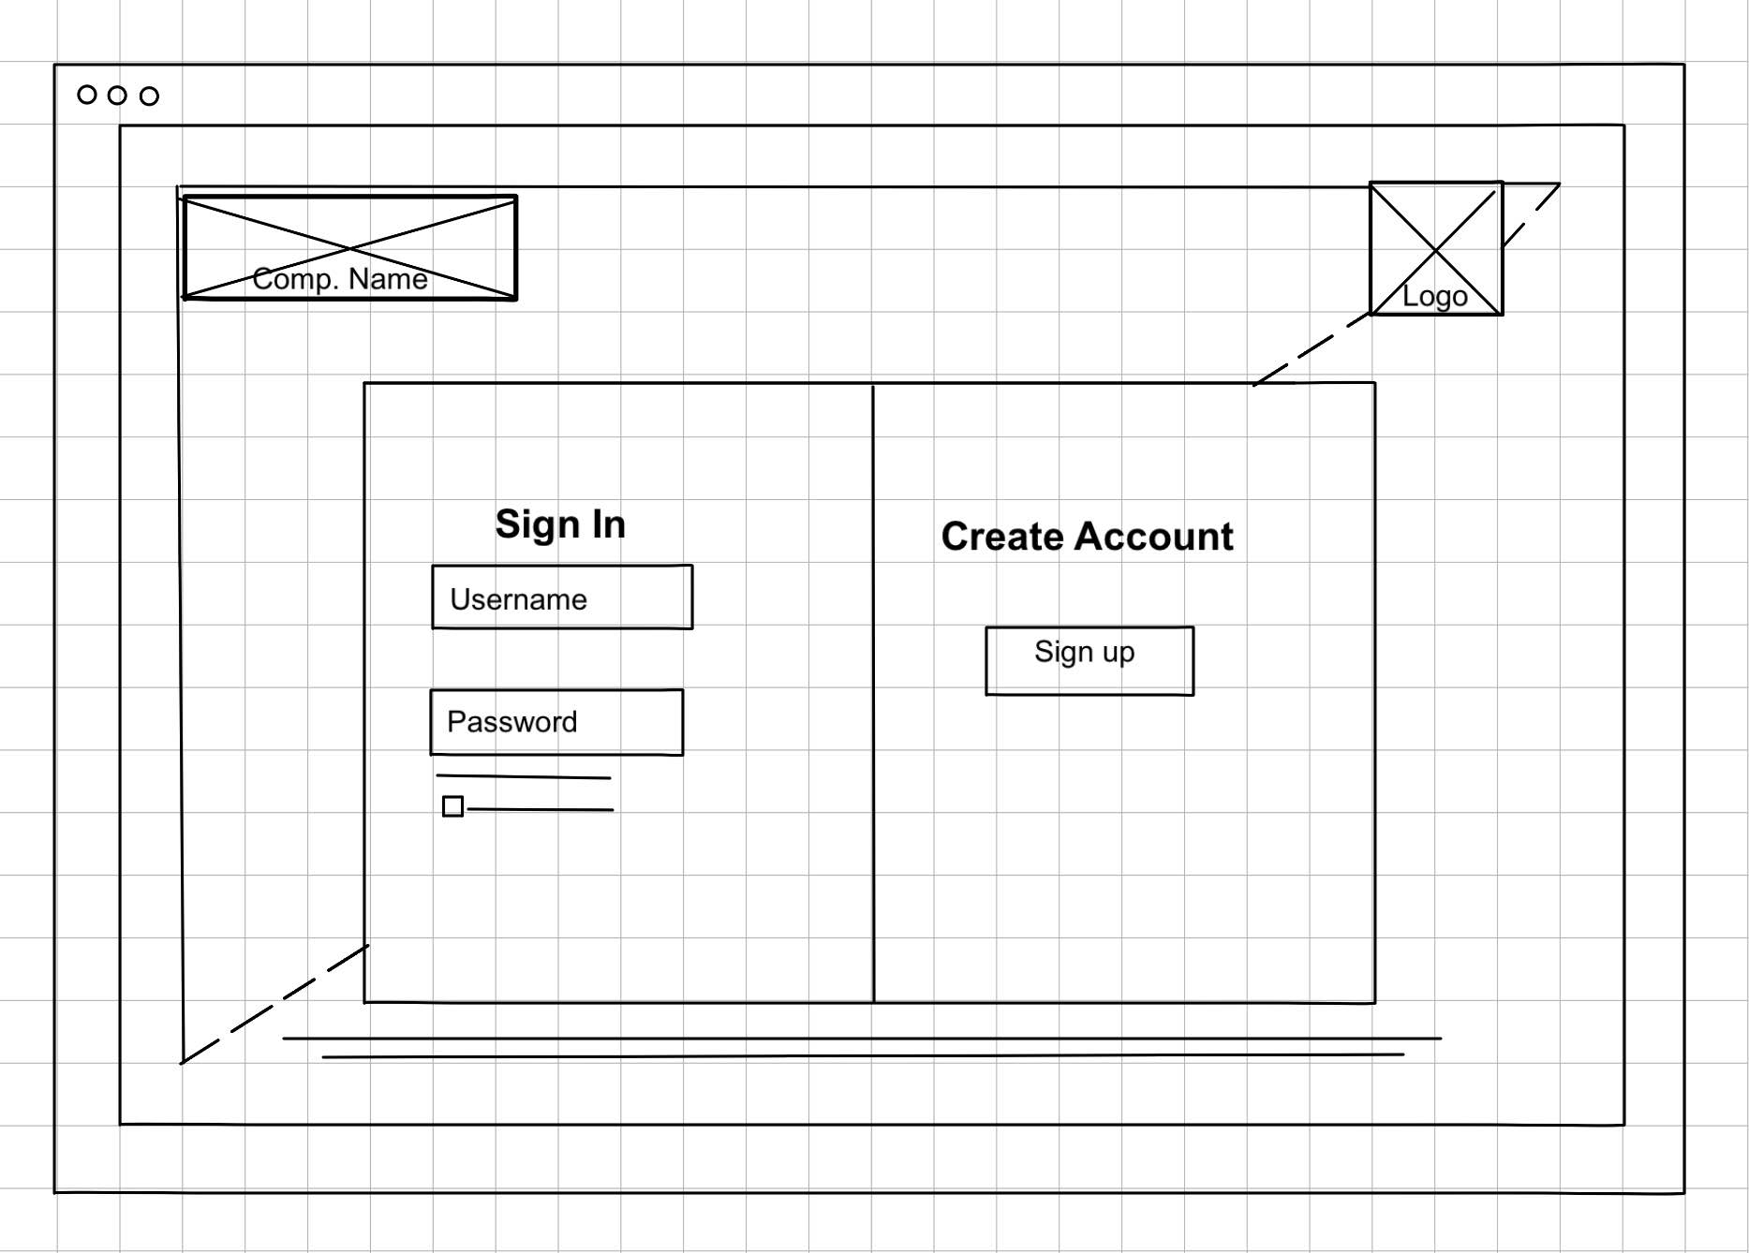

Profile Page
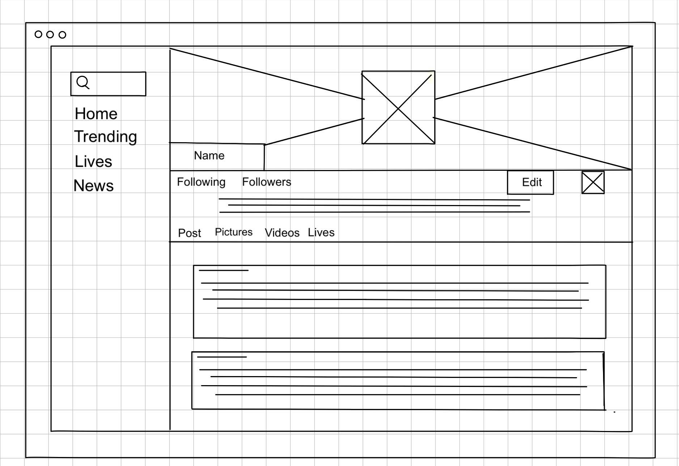
Home feed Page
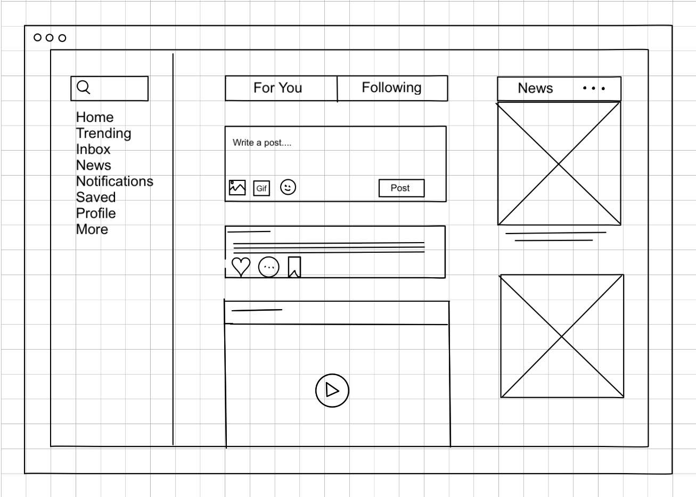
Back end pseudo Code
User Profile:
BEGIN
DISPLAY "User Profile Page"
INPUT userID
CALL fetchUserProfile(userID)
IF user profile is found THEN
DISPLAY user profile information (name, email, bio, profile picture, etc.)
DISPLAY "Edit Profile" button
DISPLAY "View Posts" button
IF "Edit Profile" button is clicked THEN
INPUT newProfileInformation (name, email, bio, profile picture, etc.)
CALL updateUserProfile(userID, newProfileInformation)
IF update is successful THEN
DISPLAY "Profile updated successfully!"
ELSE
DISPLAY "Failed to update profile. Please try again."
END IF
END IF
IF "View Posts" button is clicked THEN
CALL fetchUserPosts(userID)
DISPLAY user posts
END IF
ELSE
DISPLAY "User profile not found."
END IF
END
Posting:
BEGIN
DISPLAY "Create a New Post"
INPUT postContent
INPUT optionalMedia (image, video, etc.)
IF postContent is not empty THEN
CALL savePost(postContent, optionalMedia)
IF save is successful THEN
DISPLAY "Post created successfully!"
REDIRECT to feed
ELSE
DISPLAY "Failed to create post. Please try again."
END IF
ELSE
DISPLAY "Please enter content for your post."
END IF
END
Like Post:
BEGIN
DISPLAY "Like a Post"
INPUT userID
INPUT postID
CALL fetchPost(postID)
IF post is found THEN CALL checkIfUserLikedPost(userID, postID)
IF user has already liked the post
THEN DISPLAY "You have already liked this post."
ELSE CALL addLikeToPost(userID, postID)
IF like is successful THEN DISPLAY "Heart"
CALL updateLikeCount(postID)
ELSE DISPLAY "Failed to like the post. Please try again."
END IF
END IF
ELSE DISPLAY "Post not found."
END IF
END
ERD diagram:
